Working with React props, state.

Pre-Requisites:
- Knowledge on the HTML elements and styling
- Knowledge on the Java Script

The TCS team lead need visited to MRUD and they need User Profile Component as a real-time example, where we manage the user’s personal information (like name, age, and location) in a parent component (App.js) and pass that data to a child component (UserProfile.js) using props. The user can also update this information, and we will manage the updates using state within the child component.finally TCS team need the following pages
- Pass user data (name, age, and location) to a child component as props.
- Allow the user to update their profile, which will be handled via state in the child component.
- The updated profile information will be reflected back in the parent component using state lifting (passing the updated state back to the parent).
user-profile/
├── src/
├── App.jsx
├── UserProfile.jsx
└── index.jsx

SOLUTION:
Userprofile.jsx
import React, { useState } from "react";

const UserProfile = ({ user, onUpdateProfile }) => {
// Local state for form inputs
const [formData, setFormData] = useState(user);

// Handle input changes
const handleInputChange = (event) => {
const { name, value } = event.target;
setFormData({ ...formData, [name]: value });
};

// Handle form submission
const handleSubmit = (event) => {
event.preventDefault();
// Pass updated data back to the parent
onUpdateProfile(formData);
};

return (
<div style={{ marginTop: "20px", border: "1px solid #ccc", padding: "20px"}}>
<h2>Update Profile</h2>
<form onSubmit={handleSubmit}>
<div style={{ marginBottom: "10px" }}>
<label>
Name:{" "}
<input type="text" name="name" value={formData.name}
onChange={handleInputChange}
required
/>
</label>
</div>
<div style={{ marginBottom: "10px" }}>
<label>
Age:{" "}
<input type="number" name="age" value={formData.age}
onChange={handleInputChange}
required
/>
</label>
</div>
<div style={{ marginBottom: "10px" }}>
<label>
Location:{" "}
<input type="text"
name="location" value={formData.location}
onChange={handleInputChange}
required
/>
</label>
</div>
<button type="submit" style={{ padding: "10px 20px", cursor: "pointer" }}>
Update Profile
</button>
</form>
</div>
);
};

export default UserProfile;

App.jsx:
import React, { useState } from "react";
import UserProfile from "./UserProfile";

const App = () => {
// State to hold user data
const [userData, setUserData] = useState({
name: "subba rayudu",
age: 33,
location: "Hyderabad",
});

// Function to update user data (state lifting)
const handleProfileUpdate = (updatedData) => {
setUserData(updatedData);
};

return (
<div style={{ padding: "20px", fontFamily: "Arial, sans-serif" }}>
<h1>User Profile</h1>
<p><strong>Current Profile:</strong></p>
<ul>
<li><strong>Name:</strong> {userData.name}</li>
<li><strong>Age:</strong> {userData.age}</li>
<li><strong>Location:</strong> {userData.location}</li>
</ul>

{/* Pass user data and update handler to the child component */}
<UserProfile user={userData} onUpdateProfile={handleProfileUpdate} />
</div>
);
};

export default App;

index.jsx:
import React from "react";
import ReactDOM from "react-dom";
import App from "./App";

ReactDOM.render(
<React.StrictMode>
<App />
</React.StrictMode>,
document.getElementById("root")
);

Ouput:

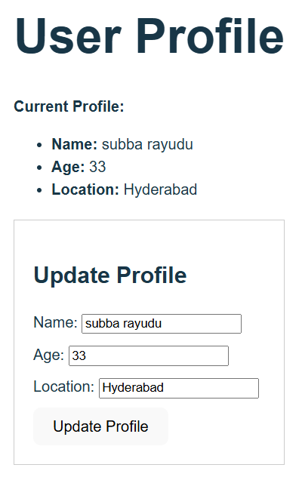
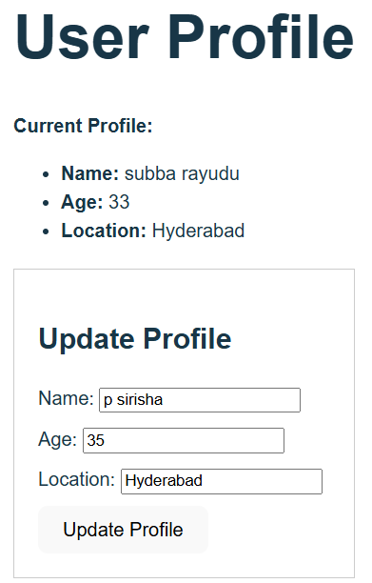

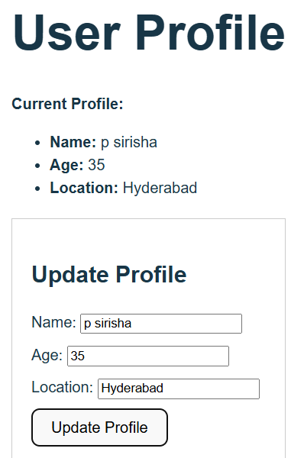

Note:
Detailed explanation of each line of the provided ReactJS UserProfile component code:

1. Import Statement
import React, { useState } from "react";
- React: The core library for building React components.
- useState: A React Hook used to create and manage state variables in functional components.

2. Component Declaration
const UserProfile = ({ user, onUpdateProfile }) => {
- UserProfile: A functional component representing the user profile form.
- { user, onUpdateProfile }: Destructures props passed from the parent component:
  - user: The current user data (name, age, location).
  - onUpdateProfile: A callback function to send updated data back to the parent component.

3. Local State Initialization
const [formData, setFormData] = useState(user);
- formData: Holds the current state of the form inputs (name, age, location).
- setFormData: A function to update formData.
- useState(user): Initializes the local state with the user object passed via props.

4. Input Change Handler
const handleInputChange = (event) => {
const { name, value } = event.target;
setFormData({ ...formData, [name]: value });
};
- handleInputChange: Updates the state (formData) whenever the user types into an input field.
- event.target: Refers to the input element triggering the event.
- { name, value }: Extracts the name (e.g., "name", "age", "location") and value from the input.
- setFormData({ ...formData, [name]: value }):
  - Uses the spread operator to copy existing state.
  - Updates the specific field ([name]) with the new value.

5. Form Submission Handler
const handleSubmit = (event) => {
event.preventDefault();
onUpdateProfile(formData);
};
- handleSubmit: Executes when the user submits the form.
- event.preventDefault(): Prevents the default browser behavior (page reload).
- onUpdateProfile(formData): Passes the updated formData back to the parent component via the onUpdateProfile callback.

6. JSX Structure
Outer Container
<div style={{ marginTop: "20px", border: "1px solid #ccc", padding: "20px" }}>
- A div that styles the container with margin, border, and padding for visual structure.
Form Title
<h2>Update Profile</h2>
- Displays the title "Update Profile" above the form.

Form Component
<form onSubmit={handleSubmit}>
- The form tag wraps input fields and handles submission via the onSubmit event, which calls handleSubmit.

Input Fields
- Name Input
<input type="text" name="name" value={formData.name}
onChange={handleInputChange}
required
/>
  - type="text": Specifies a text input.
  - name="name": Corresponds to the name property in the formData state.
  - value={formData.name}: Binds the input's value to formData.name.
  - onChange={handleInputChange}: Updates the state when the user types.
  - required: Ensures this field must be filled before submitting.
- Age Input
<input type="number" name="age" value={formData.age}
onChange={handleInputChange}
required
/>
  - type="number": Ensures only numeric input is allowed.
  - name="age": Binds to the age property in the formData state.
- Location Input
<input type="text" name="location" value={formData.location}
onChange={handleInputChange}
required
/>
  - Similar to the name input, but updates the location property in the state.

Submit Button
<button type="submit" style={{ padding: "10px 20px", cursor: "pointer" }}>
Update Profile
</button>
- type="submit": Submits the form.
- style={{ padding: "10px 20px", cursor: "pointer" }}: Adds inline styles for button size and hover cursor.

7. Component Export
export default UserProfile;
- Exports the UserProfile component for use in other files (e.g., App.js).

Workflow Recap
- Props: Parent passes user data and onUpdateProfile callback to UserProfile.
- State Management: Local formData state handles input values in the child component.
- State Updates:
  - When an input changes, handleInputChange updates formData.
  - On form submission, handleSubmit sends the updated formData back to the parent via onUpdateProfile.
- Parent Updates: Parent uses the callback to update its own state, reflecting changes globally.
This code demonstrates props passing, local state management, and state lifting in React.

